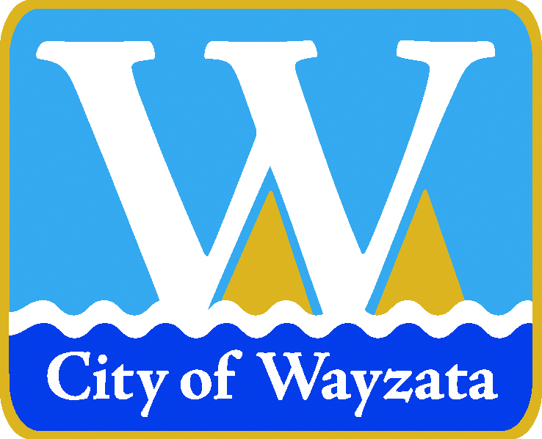

City of Wayzata

Public Hearing Notice
200 Wayzata Blvd W – Parking Lot Improvements

NOTICE IS HEREBY GIVEN that the Wayzata Planning Commission will hold a public hearing to consider a development application from the Wayzata Country Club for an expansion of their parking lot at 200 Wayzata Blvd W. The applicant has requested the following:

- Impervious Surface Variance

The Planning Commission public hearing is scheduled for Monday, February 6, 2023 at 6:30 p.m., or as soon as possible thereafter in the Wayzata Community Room, 600 Rice Street East, Wayzata, Minnesota. The Planning Commission meeting will be conducted in a hybrid manner that will allow for the public to attend remotely. Your public comments may be sent via email to PublicComment@wayzata.org. You may also send your comments in the mail to City Hall or call in your comments to City staff.

Pertinent information on this development application can be found online at https://www.wayzata.org/286/Proposed-Development-Projects. The Planning Commission meeting agenda and packet will be available on the City’s website the Friday before the meeting at http://www.wayzata.org/AgendaCenter.

Valerie Quarles
Assistant Planner
vquarles@wayzata.org
952-404-5323

Date Posted: January 19, 2023

